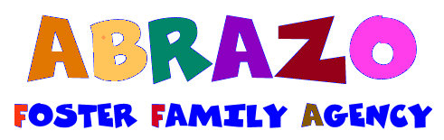

STATEMENT OF NON FIREARMS POSSESSION

I/We certify that we Do or Do Not have firearms in our home. (circle one that applies)

Address of Resource Home: ______________________________________________________

______________________ ___________ _________________________ _________
Resource Parent Signature Date Resource Parent Signature Date

STATEMENT OF FIREARMS POSSESSION

I/We certify that I/we have disclosed that we own firearms that will be kept in our home. (circle one that applies)

I/We understand that each firearm must have a trigger lock or be stored in a locked storage area. (circle one that applies)

I/We understand that all ammunition must be stored in a locked storage area. (circle one that applies)

I/We understand that children placed in our home are not, under any circumstances, to have access to said firearms, or allowed to have any other firearms in their possession unless discussed and agreed upon by the child’s treatment team. (circle one that applies)

I/We understand that any violation of the aforementioned conditions could result in immediate de-certification and removal of all children placed in my/our home. (circle one that applies)

Address of Approved Home: ______________________________________________________

__________________________ _________ ________________________ __________
Resource Parent Signature Date Resource Parent Signature Date

